## **Background:**

Over the industrialization age, the development of Robots and autonomous systems have been rapidly increasing, from the invention of the assembly line in order manufacturing factories. Robots and autonomous systems have developed to service a wide range of industry and process ranging from simple task and environment like homes to highly specialized fields like medicine and space exploration. Accompanied by the rapid developed of Artificial Intelligence, machine learning and various other deep learning solution, we currently live in a world that we can deploy this advancement into our process.

In our food delivery services, there has always been some sore area with “small orders” – quantity. The cost of servicing those orders, the commission from the merchant , the delivery fee charged to the Customers and the subsequent fees paid to the dasher all put together had made servicing our esteemed customers efficiently.

*(“Small order” – one or two snack or light meal)*

Arguably our competitors face this problem too, but being a trail blazer in this industry, it is only important that we fix this problem and stay ahead of the competition. By automating the delivery of the “small order” using delivery robots we can turn this problem into an opportunity.

The delivery robot would handle “small order” and stay to true to our timely and efficient delivery culture, ensuring our customers are satisfied from their place of comfort.

From the company perspective ,this would help lower operating cost, for the Human Dasher this enables them focus on executing large order that would pay them more, from an environmental perspective , we would lower our carbon footprint.

The idea is to fully automate the delivery of all small orders, but for starters we would focus on small delivery from restaurants within a 2 miles radius of the customer. We would also make provision for the manual control of the Robo-dasher in any event the need arises.

The application being developed aims to help the CSR /Ops. Team personnel track the Robo-dasher in real time, check the Robo-dasher distance to the delivery location, confirm if the Robo-dasher has picked up the order, and provide an overview of the Robo-dasher.

*(“CSR/Ops. Team” – Customer Support Representative / Operations Team)*

The application is meant for internal operation user and would be developed to meet every standard and quality criteria.

## **Market background:**

* **Target Users and Market**

The direct users of this product is our DoorDash operators who would be able to assist our actual customers track, route the Robo-Dasher and also manually control the Robo-dasher. However the target users in the long run , are DoorDash customers who have order and are in need of a this product.

The customers who for any reason need the CSR/Ops. Team to help the, track the Robo-Dasher with their order are the indirect target market.

* **Competitors**

Since this is an application for internal use, there are no direct competitors for this product. However as a company that prides itself on efficient, timely delivery and top notch service to our customers, this application would enable us perform better. And with some of our competitors looking to deploy autonomous technology, this application should be best in class when compared to our competitors. Baseline we should look to ensure that we serve our customers better than our competitors.

## **Product Background:**

* **Product value proposition**

Tracking a food order is the most important service a customer would need a CSR to perform. Our CSR/Ops. Team should be equipped with the tools to track an order in real time, pick-up status of the order, provide an accurate ETA of the Robo-dasher to delivery location. The application provides all these information to the CSR/Ops. Team that can be relayed to our customer, designed to provide this information in one place in a super-fast way.

* **Key Features**

1. Retrieve Client Order Information - An operator can enter the customer’s registered email ID/ phone number/order number to retrieve the order information – the order details, the restaurant, pick-up status, the Robo-Dasher ID.
2. Track Dasher Search - Upon clicking on the track dasher, the operator can see the distance to delivery location, the battery status and security state of the Robo-dasher.
3. Map- clicking the Map function opens up a map view where the operator can see the location of the Robo-Dasher on the map, and geo-coordinates.
4. Manual Control- this allows the operator to take over control of the Robo-dasher movement.

* **Potential Issues**
  + - 1. Client may have issues remembering email, alternatively ask them for their phone number.
      2. Live Status tracking in the Map view flickers 1 out of 100 times, due to the screen refreshment rate and the server response.

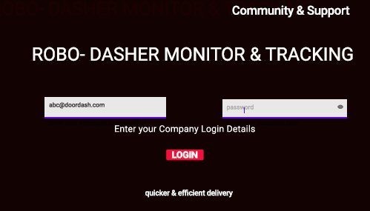

1. **How to Sign-in : Enter your Email and password and click on the Login in button , if you have an issue click on support**
2. **Click on the Track Location to help a customer track a Robo-Dasher**

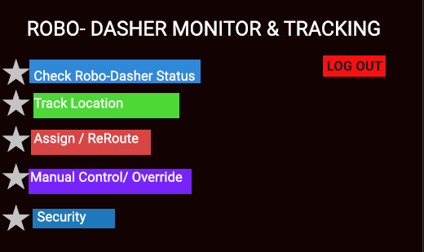

1. **Enter the Customer ID details and click on search**

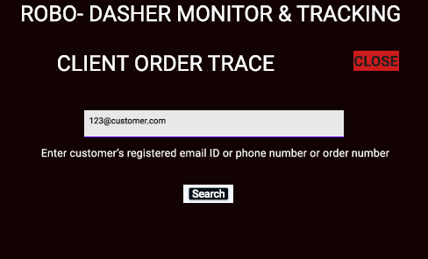

1. **Click on the search button to Track the Robo-Dasher.**

**The Robo-Dasher ID is also available on screen 4 of** [**Prototype,**](https://www.figma.com/proto/474Zqi9gBJu94ix00xPIFX/ROBO-DASHER---V2?node-id=13%3A631&scaling=scale-down&page-id=0%3A1&starting-point-node-id=2%3A286) **and is automatically filled here**

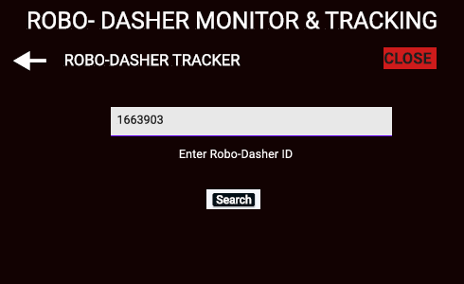

1. **Click on MAP to see map view of the Robo-Dasher location**

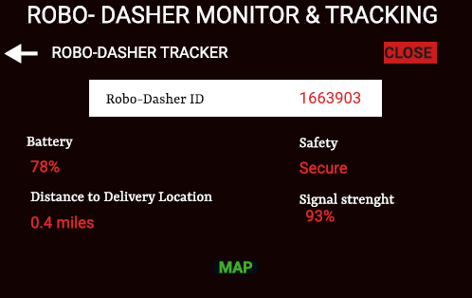

1. **Click on the buttons, to re-route, manual control or cancel as the customer need may require**

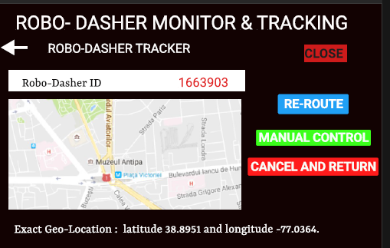

## **Pricing:**

This application is an in-house tool and would not be sold to any third party. Hence NO pricing strategy.

There would be no direct revenue from the application, but revenue would be generated form the Robo-Dasher deployment via advertising on the robots, and the delivery charge for delivery jobs done by the Robo-Dasher.